2025

UNIFIED EURO CUP
Vrbas, Banja Luka

23 - 25 May 2025

BULLETIN 1

 | 

Invitation letter

The Republic of Srpska Rafting Federation and Rafting club "KANJON" invites all Rafting Teams for the Unified R4 Rafting Euro Cup "Memorial Branka Stulic 2025" in Bosnia and Herzegovina.
Races will be held on river Vrbas - city Banja Luka in R4 Open men and R4 Open women category, in all discipline (Sprint, H2H, Slalom and Downriver) according to IRF Race rules. Category Youth and Junior will also be held if at least three teams per category are registered.

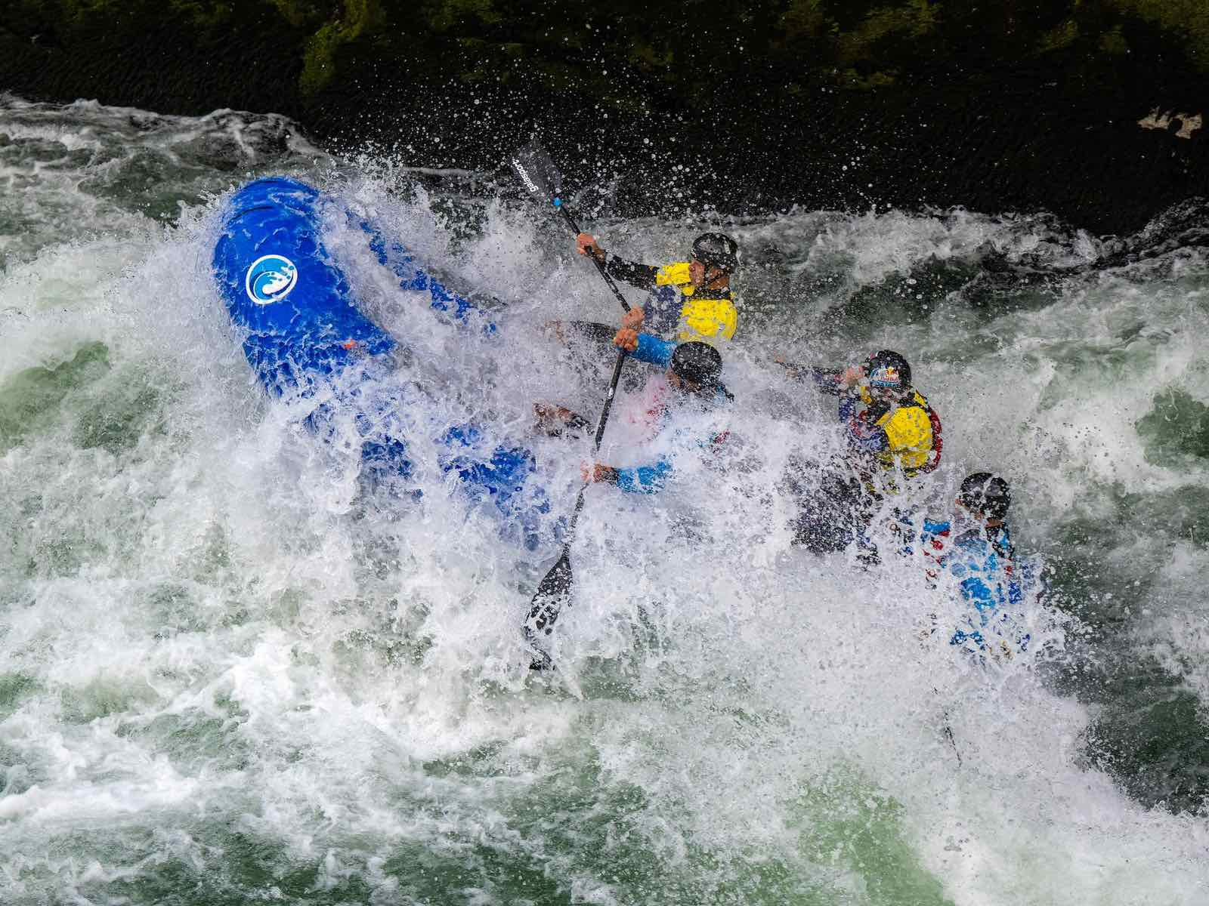

Important key dates

Event programme

Day | Programme
May 23, 2025  (Friday) | 15:00 Downriver training (''Bijeli potok'' - Rafting center Kanjon in Karanovac)
May 23, 2025  (Friday) | 20:00 Captains meeting and registration (Rafting center Kanjon in Karanovac)
May 24, 2025 (Saturday) | 11:00 Start of R4 Slalom – Canyon Tijesno - slalom course
May 24, 2025 (Saturday) | 13:00 Start of R4 Sprint– Canyon Tijesno - slalom course
May 24, 2025 (Saturday) | 13:40 Start of R4 H2H – Canyon Tijesno - slalom course
May 24, 2025 (Saturday) | 19:00 Captains meeting (Rafting center Kanjon in Karanovac)
May 25, 2025  (Sunday) | 10:00 Start of R4 Downriver (''Bijeli potok'' - Rafting center Kanjon in Karanovac)
May 25, 2025  (Sunday) | 12:00 Medal ceremony (Rafting center Kanjon in Karanovac)

Rules
The event will be organised in accordance with the IRF Race Rules (https://internationalrafting.com/racing/race-rules/).

Registration deadline and procedure

All teams must to register until May 04 to Goran Lolic by email raftingsrpske@gmail.com or lola.judge05@gmail.com.
To support the Local Organising Committee in the preparation of the event, the National Clubs are invited to register their Teams as soon as possible. There is no limit for teams’ number for each Club.

Categories
- Open Men and Women

Location
Races will be held on river Vrbas - city Banja Luka, Bosnia and Herzegovina.

How to reach Banja Luka

Banja Luka city: https://maps.app.goo.gl/ha8mZ82cRqXuHScC8
Rafting center Karanovac: https://maps.app.goo.gl/yyitY5pfy2rQ8sDu9

Level of the race courses

River Vrbas, class 3

Contact
raftingsrpske@gmail.com or lola.judge05@gmail.com

Race Director: Aleksandar Pastir (acoraftbl@gmail.com)

Accomodation in Banja Luka: We will help you to find accommodation at the best prices in the city. To make bookings like this, please contact: Mrs Sanja Brkic, mobile: +387 66 714 169, e-mail: sanja@guidelinebl.com.

For other informations like a transportation, restaurants, nigh life, etc., you can visit website of Touristic organizationof Banja Luka at www.banjaluka-tourism.com.

Participation Fee

Entry fee is 70 EUR per team and should be paid on first Captains meeting.

Security at the venue
All competitors as well as officials will have accreditation passes enabling their access to the designated areas. General security will be guaranteed by a local security agency.
It is not guaranteed any responsibility for missing equipment and other goods.

Access pass and parking
Parking places will be organised. Every team will be allowed to park one van with the trailer.

Water safety
Rescue service in the competition area will be organised during the competition days.

Medical Insurance
Organising Committee kindly asks all participants of the event to ensure medical insurance policy in their countries. Organising Committee will not cover any expenses in connection with hospital or dental treatment.

